Batch: E-2 Roll No.: 16010123325

Experiment No. 5

Title: Queries based Views and Triggers

Objective: To be able to use SQL view and triggers.

Expected Outcome of Experiment:
CO3: Utilize SQL for Relational Database Operations
Books/ Journals/ Websites referred:

1. Dr. P.S. Deshpande, SQL and PL/SQL for Oracle 10g.Black book, Dreamtech Press
2. www.db-book.com
3. Korth, Slberchatz, Sudarshan : “Database Systems Concept”, 5th Edition , McGraw
Hill
4. Elmasri and Navathe,”Fundamentals of database Systems”, 4th Edition,PEARSON
Education.

Resources used: Postgresql

Theory
View
Views are pseudo-tables. That is, they are not real tables; nevertheless appear as ordinary tables to SELECT. A view can represent a subset of a real table, selecting certain columns or certain rows from an ordinary table. A view can even represent joined tables. Because views are assigned separate permissions, you can use them to restrict table access so that the users see only specific rows or columns of a table.

A view can contain all rows of a table or selected rows from one or more tables. A view can be created from one or many tables, which depends on the written PostgreSQL query to create a view.
Views, which are kind of virtual tables, allow users to do the following −
- Structure data in a way that users or classes of users find natural or intuitive.
- Restrict access to the data such that a user can only see limited data instead of complete table.
- Summarize data from various tables, which can be used to generate reports.

Since views are not ordinary tables, you may not be able to execute a DELETE, INSERT, or UPDATE statement on a view. However, you can create a RULE to correct this problem of using DELETE, INSERT or UPDATE on a view.
Syntax
CREATE [TEMP | TEMPORARY] VIEW view_name AS
SELECT column1, column2.....
FROM table_name
WHERE [condition];
Ex:
CREATE VIEW COMPANY-VIEW AS
SELECT ID, NAME, AGE
FROM COMPANY;

Display view:
select * from Company-View
Insert record into view:
Insert into Company-View values (123,’alpha’, 10)
select * from Company

Dropping Views
Syntax: DROP VIEW view_name;

Triggers
A trigger is a stored procedure in a database that automatically invokes whenever a special event in the database occurs. By using SQL triggers, developers can automate tasks, ensure data consistency, and keep accurate records of database activities.
For example, a trigger can be invoked when a row is inserted into a specified table or wwhen specific table columns are updated.
Key Features of SQL Triggers:
Automatic Execution: Triggers fire automatically when the defined event occurs (e.g., INSERT, UPDATE, DELETE).
Event-Driven: Triggers are tied to specific events that take place within the database.
Table Association: A trigger is linked to a specific table or view, and operates whenever changes are made to the table’s data.
The basic syntax of creating a trigger is as follows −
CREATE TRIGGER trigger_name [BEFORE|AFTER|INSTEAD OF] event_name
ON table_name
[
-- Trigger logic goes here....
];
- trigger_name: The name of the trigger to be created.
- BEFORE | AFTER: Specifies whether the trigger is fired before or after the triggering event (INSERT, UPDATE, DELETE).
- {INSERT | UPDATE | DELETE}: Specifies the operation that will activate the trigger.
- table_name: The name of the table the trigger is associated with.
- FOR EACH ROW: Indicates that the trigger is row-level, meaning it executes once for each affected row. (You can optionally specify FOR EACH ROW after table name.
- )
- trigger_body: The SQL statements to be executed when the trigger is fired.

The following is the syntax of creating a trigger on an UPDATE operation on one or more specified columns of a table as follows −
CREATE TRIGGER trigger_name [BEFORE|AFTER] UPDATE OF column_name
ON table_name
[
-- Trigger logic goes here....
];

To use the PostgreSQL CREATE TRIGGER statement to create a trigger.
To create a new trigger in PostgreSQL, you follow these steps:
● First, create a trigger function using CREATE FUNCTION statement.
● Second, bind the trigger function to a table by using CREATE TRIGGER statement.
Example :
Suppose that when the name of an employee changes, you want to log it in a separate table called employee_audits.
employee
emp_id | fname | lname | age | salary
--------+-------+---------+-----+----------
1 | John | Doe | 30 | 50000.00
2 | Jane | Smith | 25 | 60000.00
3 | Alice | Johnson | 35 | 70000.00
(3 rows)
Employee_audit

emp_id | fname | ChangeOn |
--------+------+---------
CREATE OR REPLACE FUNCTION log_last_name_changes()
RETURNS TRIGGER AS $$
BEGIN
INSERT INTO employee_audits(employee_id,last_name,changed_on)
VALUES(OLD.id,OLD.last_name,now());
RETURN NEW;
END;
$$ language plpgsql;

CREATE TRIGGER last_name_changes
BEFORE UPDATE
ON employees
FOR EACH ROW
EXECUTE PROCEDURE log_last_name_changes();
select * from employee;

UPDATE employee
SET lname = 'Kulkarni'
WHERE ID = 1

select * from semployee
select * from employee_audit

Implementation Screenshots (Problem Statement, Query and Screenshots of Results):

Operations on view

- Selecting Active Patients with Doctors
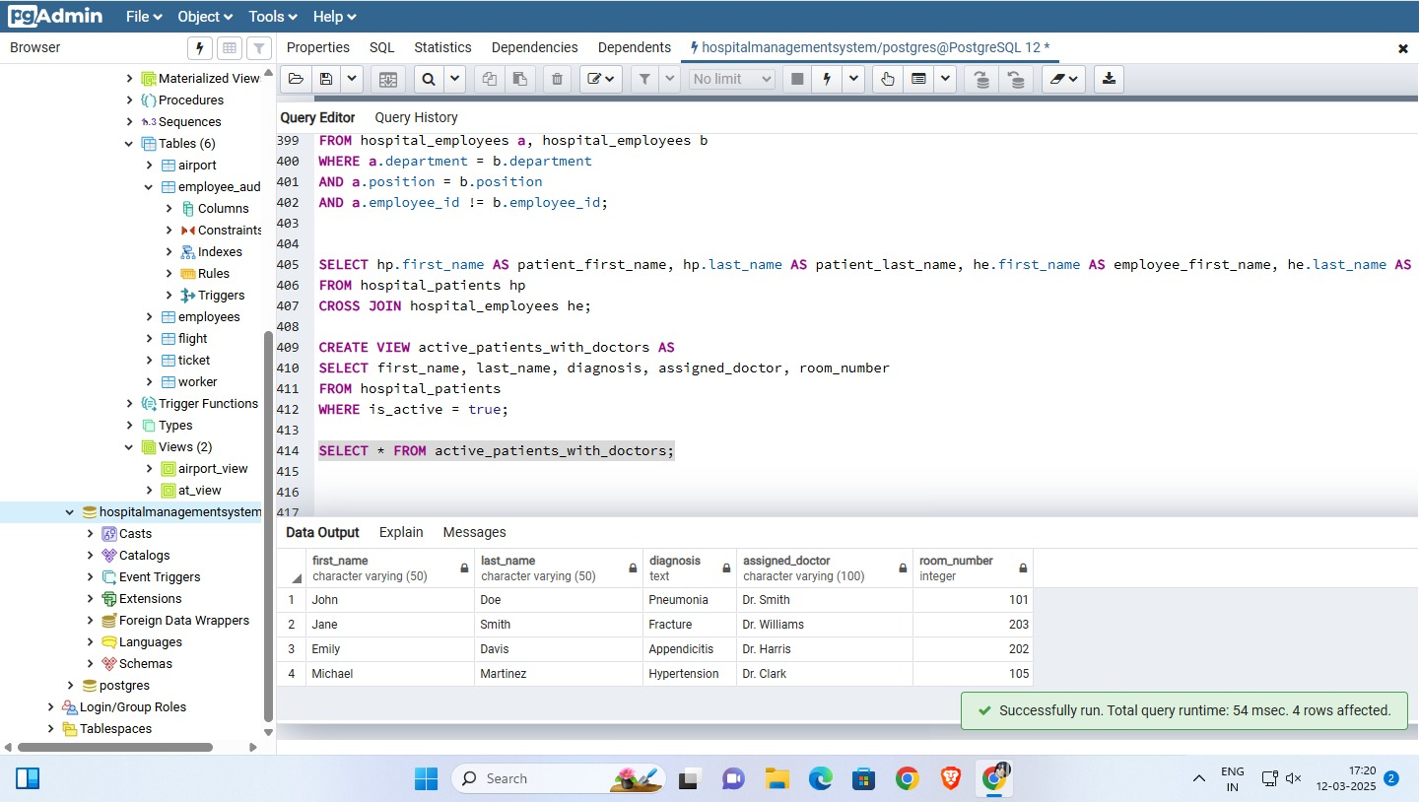

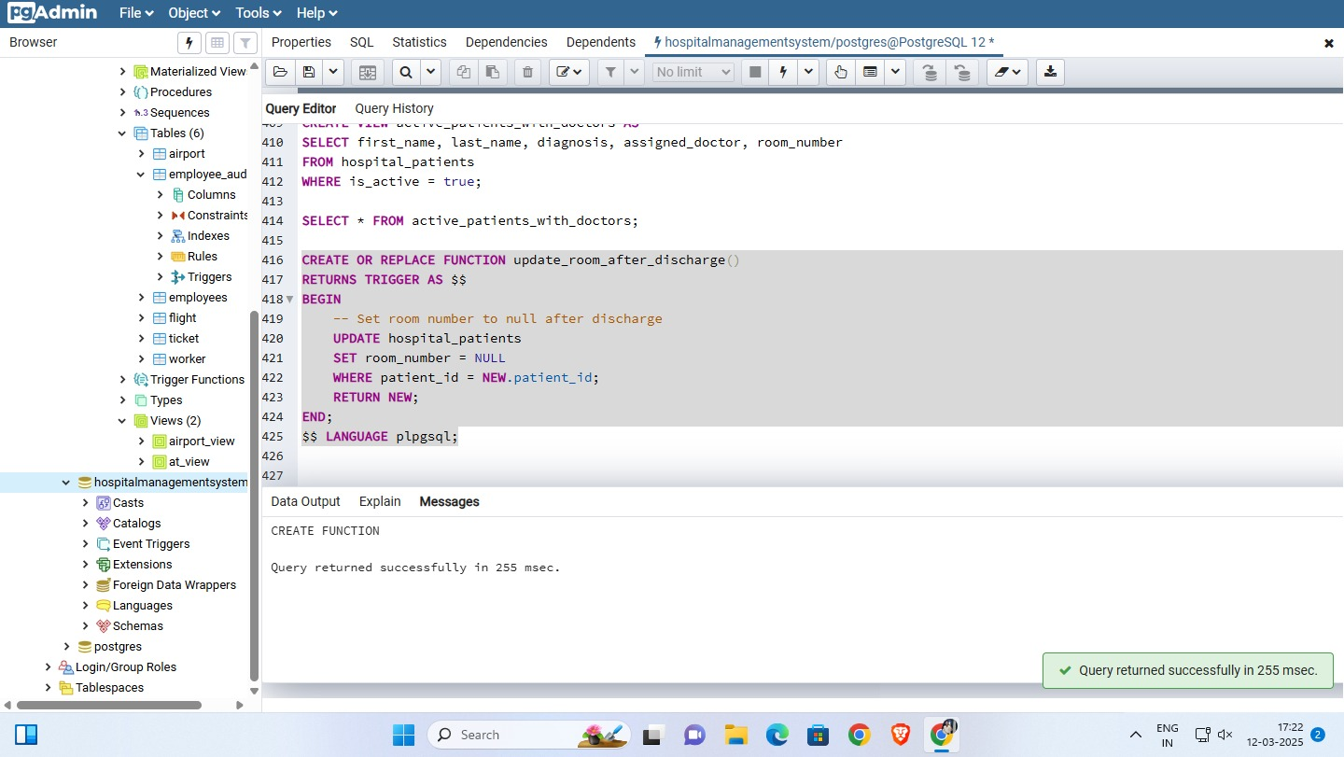

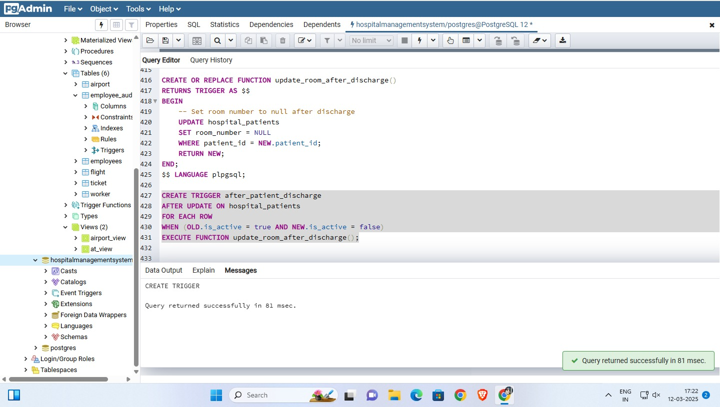

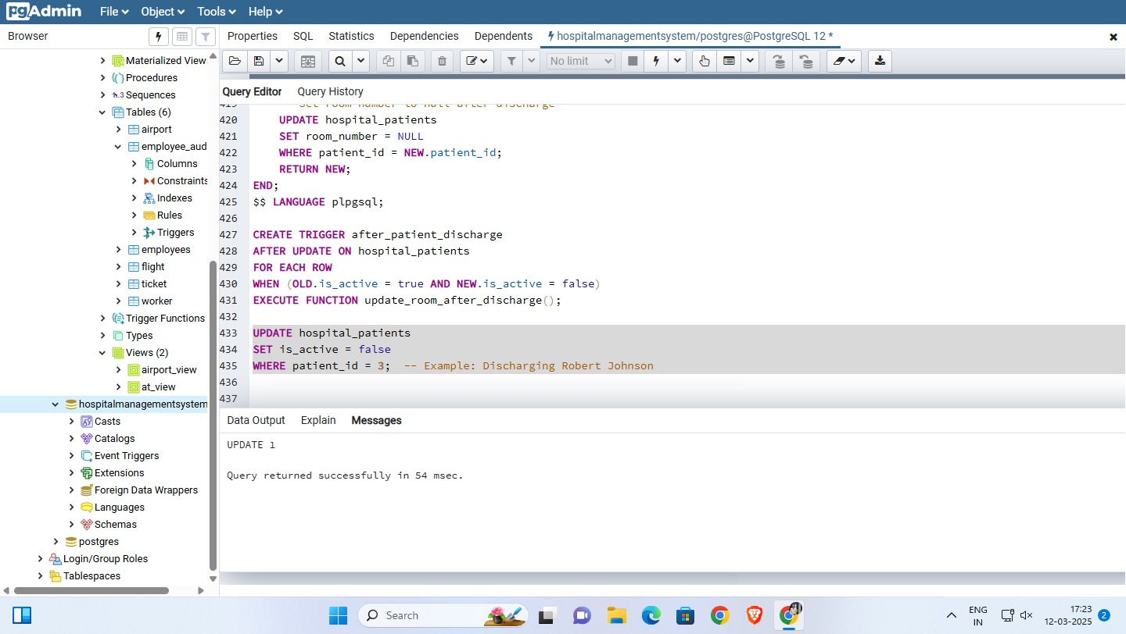
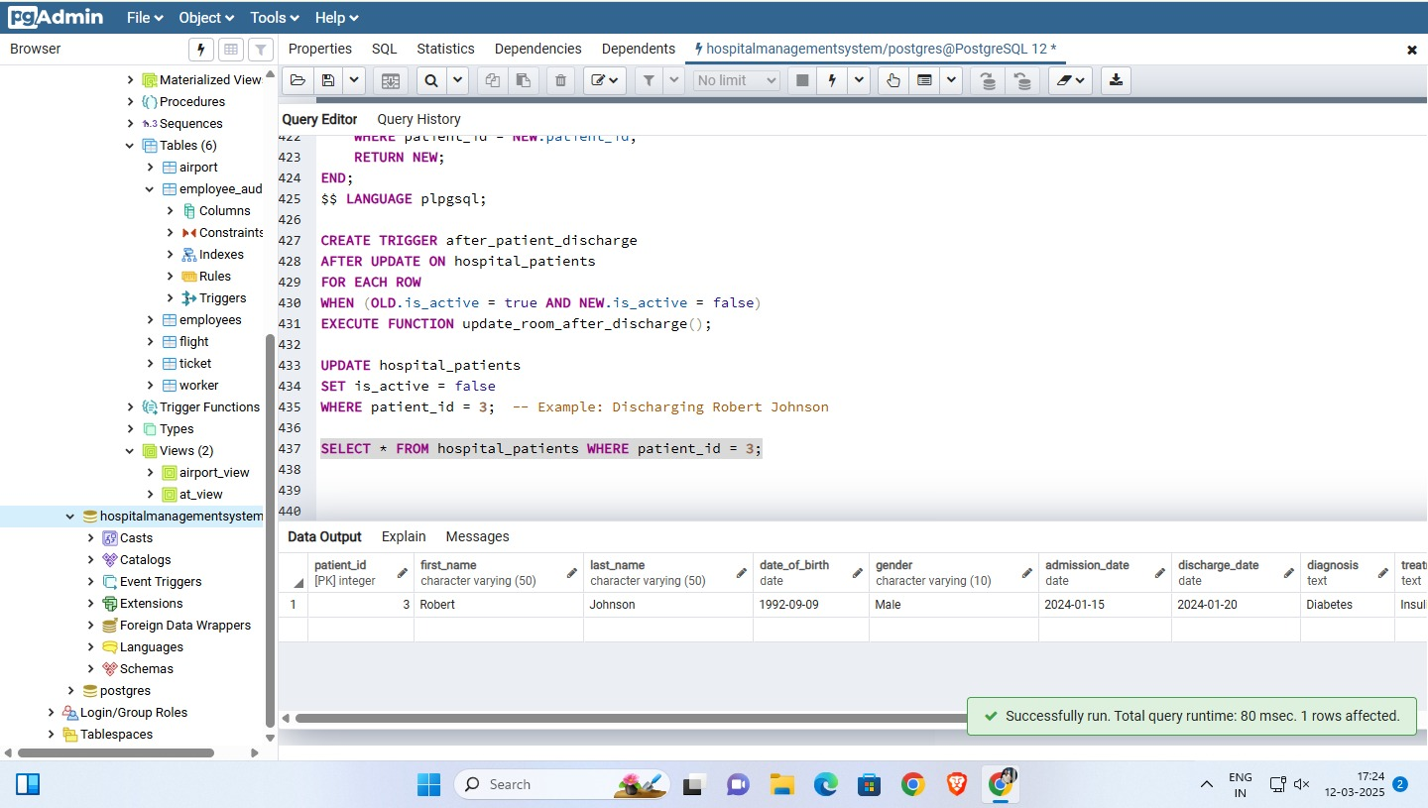

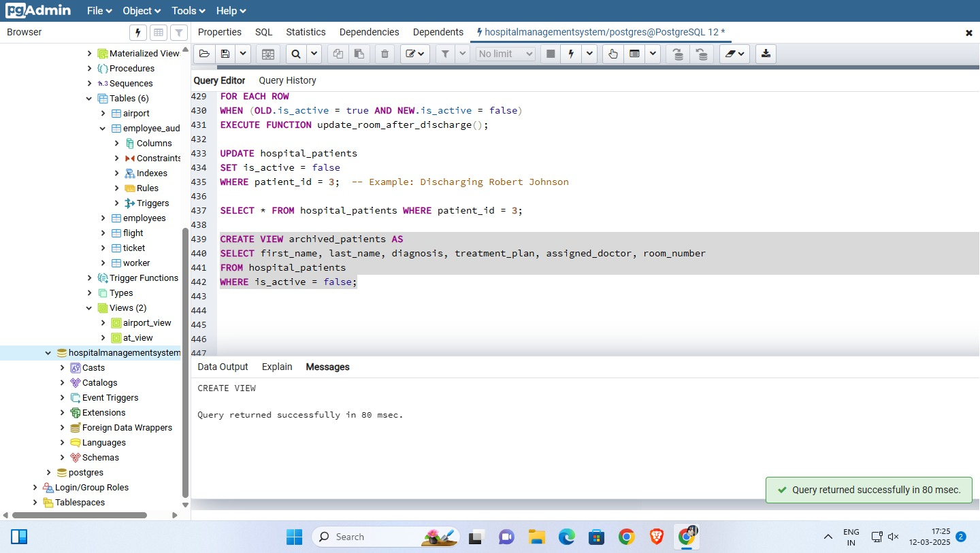
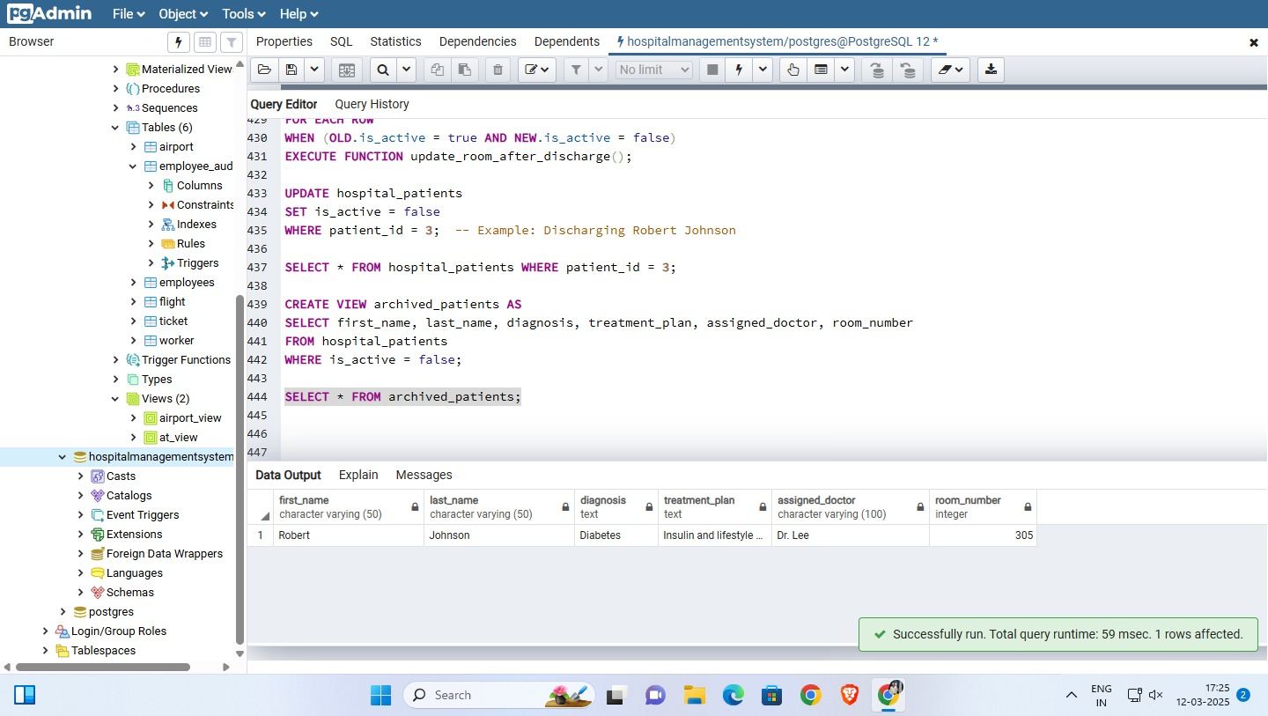

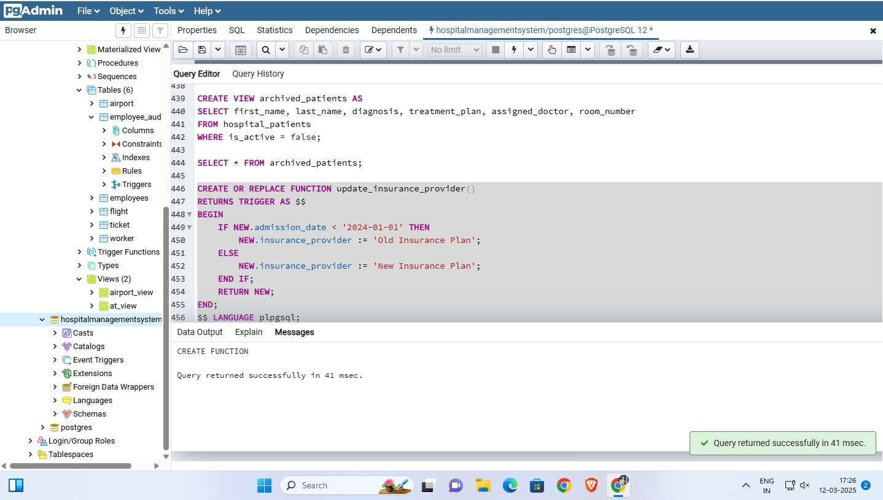

TRIGGER

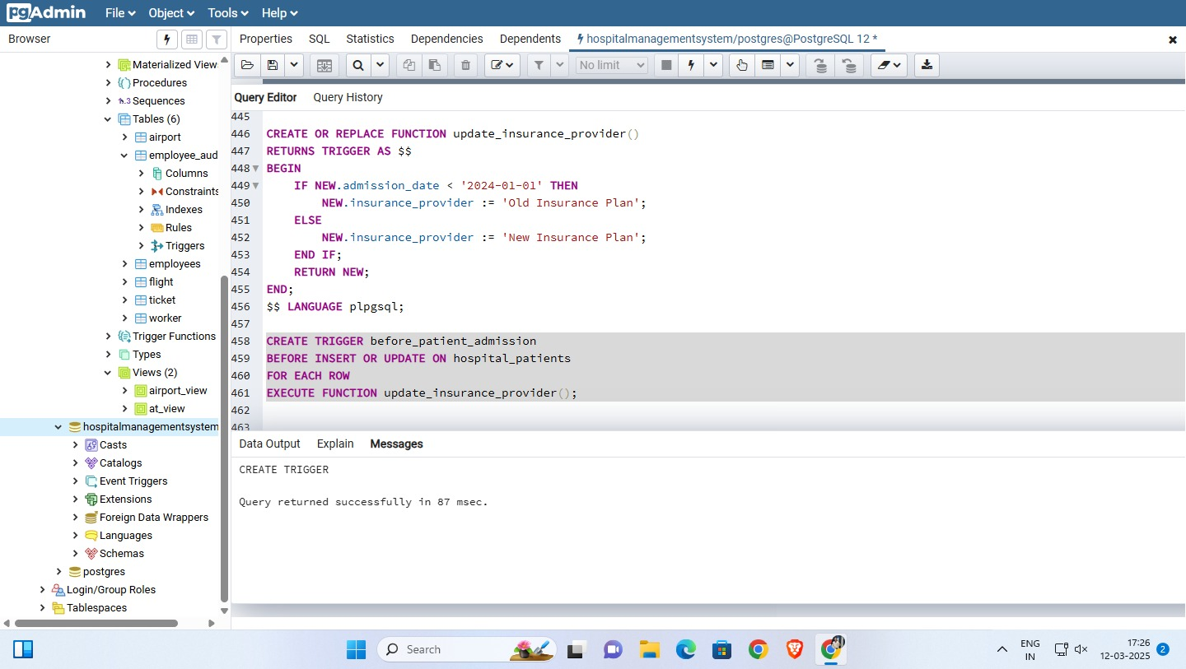

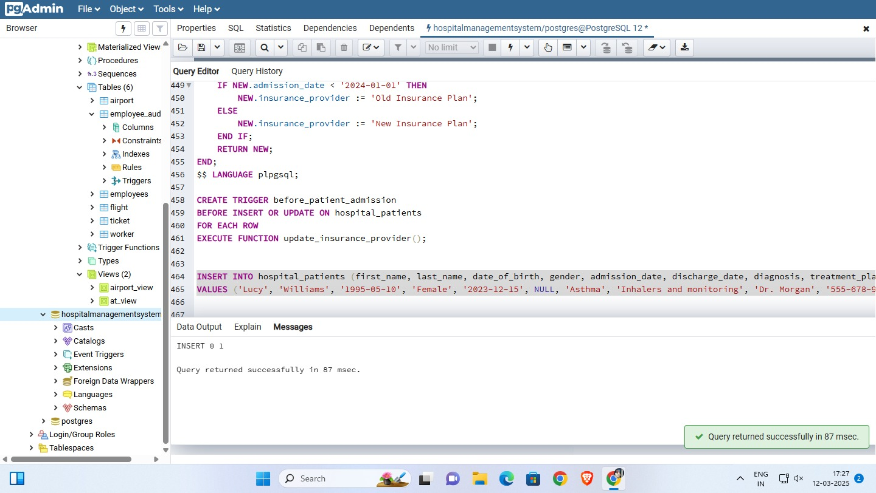
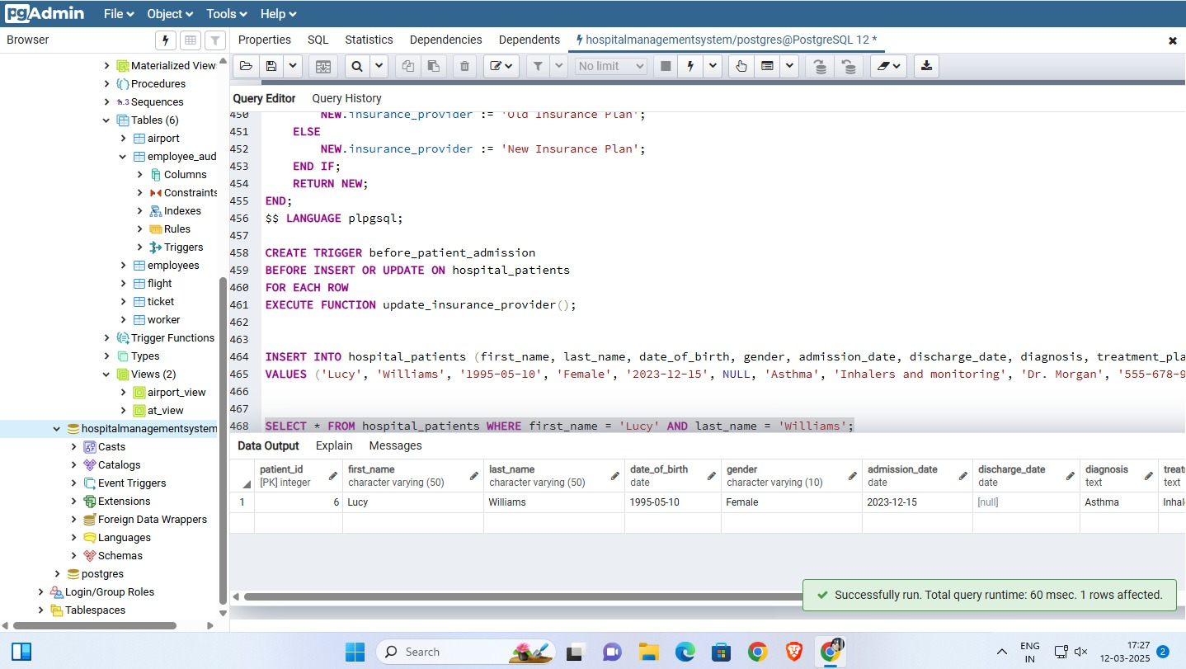

Conclusion:
The above experiment highlights working with SQL queries based on views and triggers on our database.

Post Lab Questions:

What is a view in SQL, and how does it differ from a table?
A view in SQL is a virtual table that is based on the result of a SQL query. Unlike a table, a view does not store data permanently; instead, it dynamically retrieves data from the underlying tables whenever accessed. Views are useful for simplifying complex queries, restricting access to certain columns, and improving security.

Write a query to create a view that displays only Fname, Lname, and Salary from the employee table.
CREATE VIEW EmployeeView AS
SELECT Fname, Lname, Salary
FROM employee;

Write a query to drop the trigger trg_city_update from the employee table.
DROP TRIGGER trg_city_update ON employee;

